**Unit Testing Document**

Mainframe Tour Project

Author: Kondreddy Sumanth Kumar Reddy  
**Mainframe ID:** OZA136  
Project Name: Mainframe Project on Tour

**TABLE OF CONTENTS**

**1.** **Unit Test Cases** 3

**1.1** **Test Case ID: TC01** 3

**1.2** **Test Case ID: TC02** 4

**1.3** **Test Case ID: TC03** 5

**1.4** **Test Case ID: TC04** 6

**1.5** **Test Case ID: TC05** 7

**1.6** **Test Case ID: TC06** 9

**1.7** **Test Case ID: TC07** 10

**1.8** **Test Case ID: TC08** 12

**2.** **Version History** 13

**Program Name: OZA136.SUMANTH.PROJECT.COBOL(TOUR)**

## **Unit Test Cases**

### **Test Case ID: TC01**

**Test Case Description:** Verify the creation of the TOUR_DETAILS table with correct column definitions.

**Input Data:**

CREATE TABLE TOUR_DETAILS (

TOUR_PLACE CHAR(15) NOT NULL PRIMARY KEY,

TOUR_GUIDE CHAR(10),

LANGUAGE CHAR(3) NOT NULL

CHECK (LANGUAGE IN ('TAM', 'ENG')),

TOUR_DATE DATE NOT NULL,

GROUP_SIZE INTEGER NOT NULL,

PRICE_PER_HEAD INTEGER NOT NULL

) IN OZA136DB.OZA136TS;

**Output Data:**

TOUR_DETAILS table created with columns: TOUR_PLACE, TOUR_GUIDE, LANGUAGE, TOUR_DATE, GROUP_SIZE, PRICE_PER_HEAD.

**Conclusion: PASS**

The table was created successfully with the columns and data types.

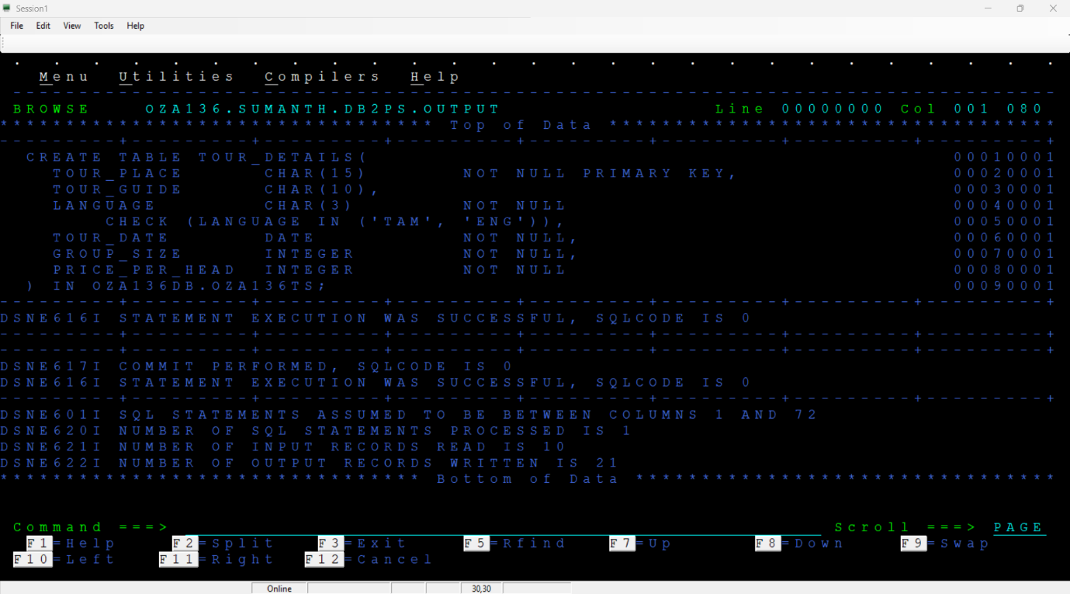

### **Test Case ID: TC02**

**Test Case Description:** Verify the creation of the SEASON_DISCOUNT table with correct column definitions.

**Input Data:**

CREATE TABLE SEASON_DISCOUNT (

TOUR_PLACE CHAR(15) NOT NULL PRIMARY KEY,

FINAL_PRICE INTEGER NOT NULL,

GUIDE CHAR(10),

DISCOUNT INTEGER NOT NULL,

DATE DATE NOT NULL,

GROUP_DISCOUNT INTEGER NOT NULL

) IN OZA136DB.OZA136TS;

**Output Data:**

SEASON_DISCOUNT table created with columns: TOUR_PLACE, FINAL_PRICE, GUIDE, DISCOUNT, DATE, GROUP_DISCOUNT.

**Conclusion: PASS**

The table has created successfully with the specified columns and data types.

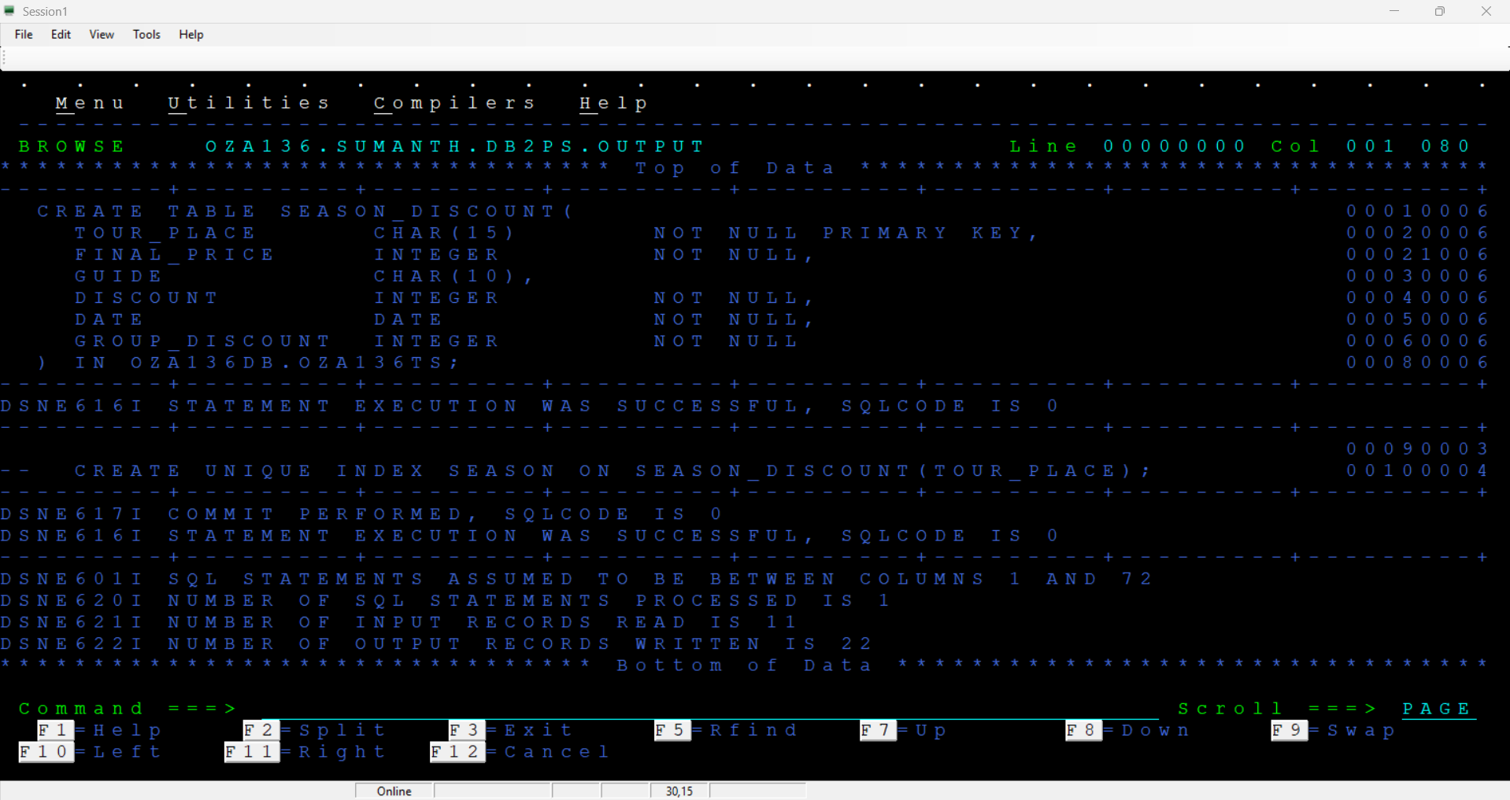

### **Test Case ID: TC03**

**Test Case Description:** Insert sample data into the TOUR_DETAILS table.

**Input Data:**

INSERT INTO TOUR_DETAILS VALUES

('PAMBANBRIDGE', 'HARI', 'TAM', '2014-09-30', 16, 2500);

INSERT INTO TOUR_DETAILS VALUES

('MAHABALIPURAM', NULL, 'TAM', '2014-09-01', 2, 1500);

INSERT INTO TOUR_DETAILS VALUES

('THENI', 'ARUL', 'ENG', '2014-09-02', 10, 2000);

INSERT INTO TOUR_DETAILS VALUES

('KALLANAI DAM', 'MANI', 'TAM', '2014-09-20', 5, 1800);

INSERT INTO TOUR_DETAILS VALUES

('VELLORFORT', NULL, 'ENG', '2014-09-01', 1, 1250);

INSERT INTO TOUR_DETAILS VALUES

('MARINABEACH', 'ANNY', 'ENG', '2014-09-29', 18, 1000);

INSERT INTO TOUR_DETAILS VALUES

('MADURAITEMPLE', 'PRIYA', 'TAM', '2014-09-18', 25, 2680);

INSERT INTO TOUR_DETAILS VALUES

('KOVALAM', 'SRUTHI', 'ENG', '2014-09-21', 22, 2500);

INSERT INTO TOUR_DETAILS VALUES

('METTUR DAM', 'RUPA', 'TAM', '2014-09-21', 21, 2200);

**Output Data:**

TOUR_DETAILS contains:

('PAMBANBRIDGE', 'HARI', 'TAM', '2014-09-30', 16, 2500)

('MAHABALIPURAM', NULL, 'TAM', '2014-09-01', 2, 1500)

('THENI', 'ARUL', 'ENG', '2014-09-02', 10, 2000)

('KALLANAI DAM', 'MANI', 'TAM', '2014-09-20', 5, 1800)

('VELLORFORT', NULL, 'ENG', '2014-09-01', 1, 1250)

('MARINABEACH', 'ANNY', 'ENG', '2014-09-29', 18, 1000)

('MADURAITEMPLE', 'PRIYA', 'TAM', '2014-09-18', 25, 2680)

('KOVALAM', 'SRUTHI', 'ENG', '2014-09-21', 22, 2500)

('METTUR DAM', 'RUPA', 'TAM', '2014-09-21', 21, 2200)

**Conclusion: PASS**

All sample records were inserted successfully into the TOUR_DETAILS table.

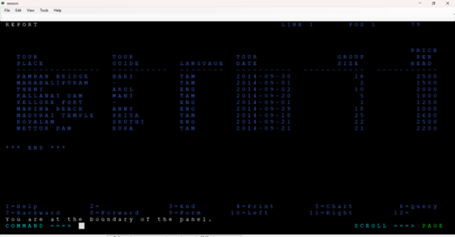

### **Test Case ID: TC04**

**Test Case Description:** Handle records where the TOUR_GUIDE field contains NULL values.

**Input Data:**

Records in TOUR_DETAILS with NULL TOUR_GUIDE:

* MAHABALIPURAM, NULL, TAM, 2014-09-01, 2, 1500
* VELLORE FORT, NULL, ENG, 2014-09-01, 1, 1250

Cursor filter: GROUP_SIZE > 1 AND PRICE_PER_HEAD > 1000



**Output Data:**

OUTODEL:

**MAHABALIPURAM YTD TAM 2014-09-01 02 01500**

TOUR_DETAILS table after processing:

* MAHABALIPURAM record deleted (TOUR_GUIDE is NULL).
* VELLORE FORT not processed (does not meet cursor criteria: GROUP_SIZE = 1).

**Conclusion: PASS**

Records with NULL TOUR_GUIDE were processed as expected: written to OUTODEL and deleted from TOUR_DETAILS.

TOUR_DETAILS Table:

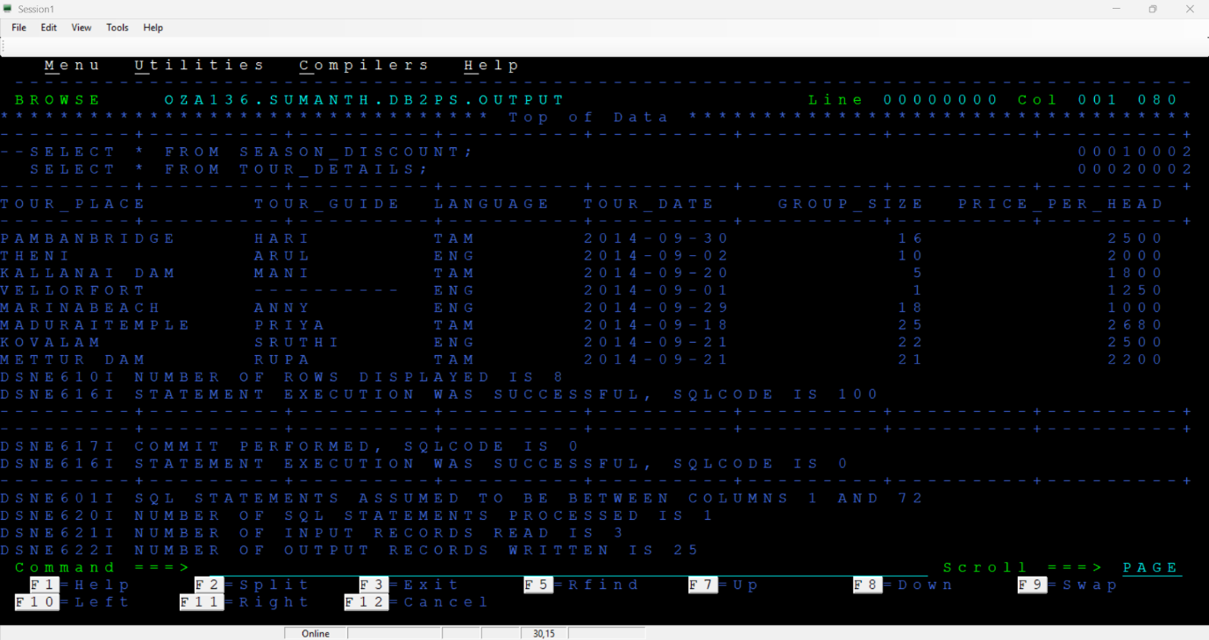

OUTODEL file:

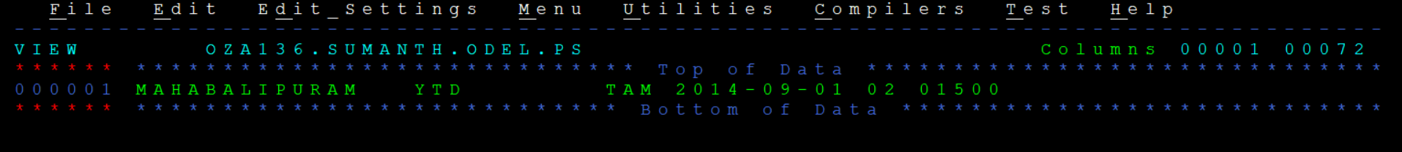

### **Test Case ID: TC05**

**Test Case Description:** Compute the discount for GROUP_SIZE = 5.

**Input Data:**

Record: KALLANAI DAM, MANI, TAM, 2014-09-20, 5, 1800

Formula: DISCOUNT = PRICE_PER_HEAD * 0.01

Expected: DISCOUNT = 1800 * 0.01 = 18



**Output Data:**

Calculated DISCOUNT: 18

OUTTOUR record:

**KALLANAI DAM 0001700 MANI 000000018 2014-09-20 000000090 05**

GROUP_DISCOUNT (DISCOUNT * GROUP_SIZE): 18 * 5 = 90

FINAL_PRICE (DISCOUNT between 10 and 20): 1800 - 90 - 10 = 1700

**Conclusion: PASS**

Discount calculated correctly for GROUP_SIZE = 5.

OUTTOUR file:

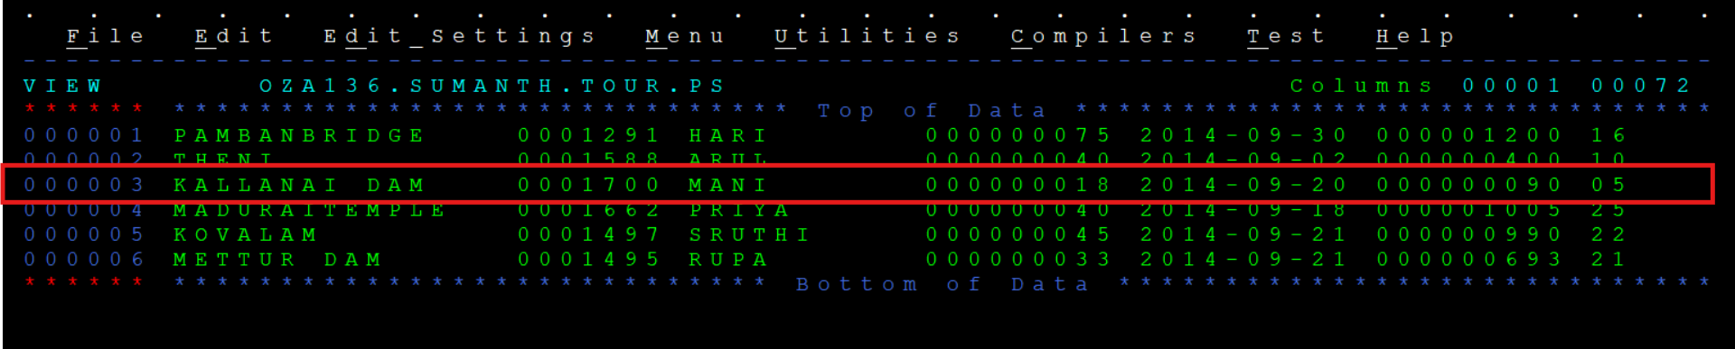

SEASON_DISCOUNT Table:

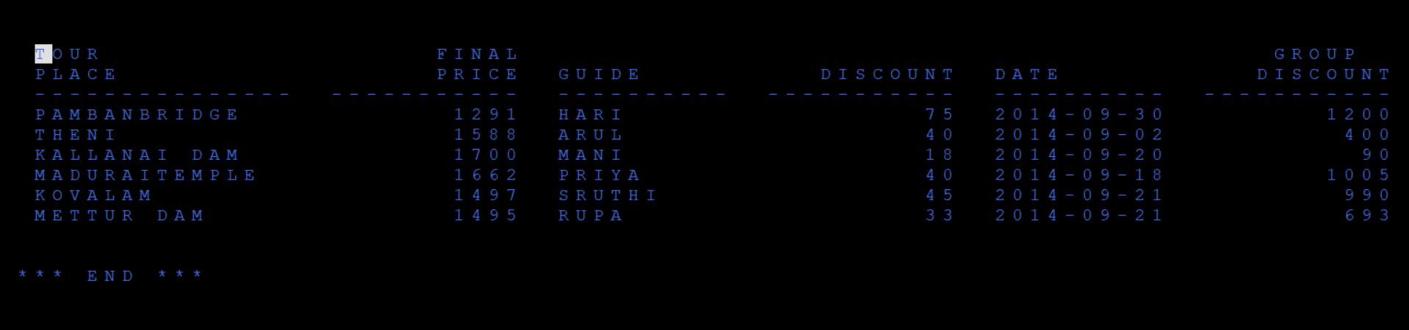

### **Test Case ID: TC06**

**Test Case Description:** Compute the discount for GROUP_SIZE between 6 and 10, filtering by LANGUAGE = "ENG".

**Input Data:**

Record: THENI, ARUL, ENG, 2014-09-02, 10, 2000

Formula: DISCOUNT = PRICE_PER_HEAD * 0.02

Expected: DISCOUNT = 2000 * 0.02 = 40



**Output Data:**

Calculated DISCOUNT: 40

OUTTOUR record:

**THENI 0001588 ARUL 000000040 2014-09-02 000000400 10**

GROUP_DISCOUNT: 40 * 10 = 400

FINAL_PRICE (DISCOUNT between 21 and 40): 2000 - 400 - 12 = 1588

**Conclusion: PASS**

Discount calculated correctly for GROUP_SIZE between 6 and 10 with LANGUAGE = "ENG".

OUTTOUR file:

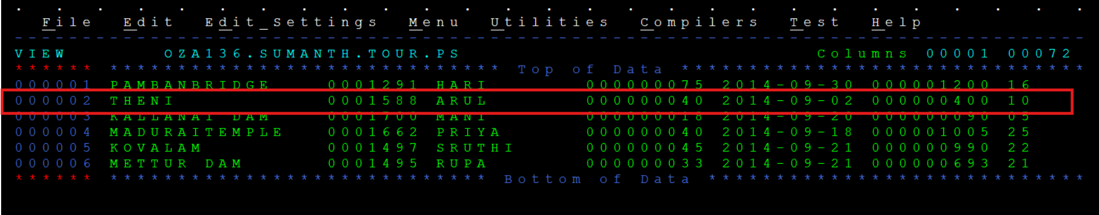

SEASON_DISCOUNT Table:



### **Test Case ID: TC07**

**Test Case Description:** Determine the FINAL_PRICE for discounts ranging between 41 and 50.

**Input Data:**

Record: KOVALAM, SRUTHI, ENG, 2014-09-21, 22, 2500

DISCOUNT: 45

GROUP_DISCOUNT: 45 * 22 = 990

Formula: FINAL_PRICE = PRICE_PER_HEAD - GROUP_DISCOUNT - 13

Expected: FINAL_PRICE = 2500 - 990 - 13 = 1497



**Output Data:**

Calculated FINAL_PRICE: 1497

OUTTOUR record:

**KOVALAM 0001497 SRUTHI 000000045 2014-09-21 000000990 22**

**Conclusion: PASS**

FINAL_PRICE calculated correctly for DISCOUNT between 41 and 50.

OUTTOUR file:

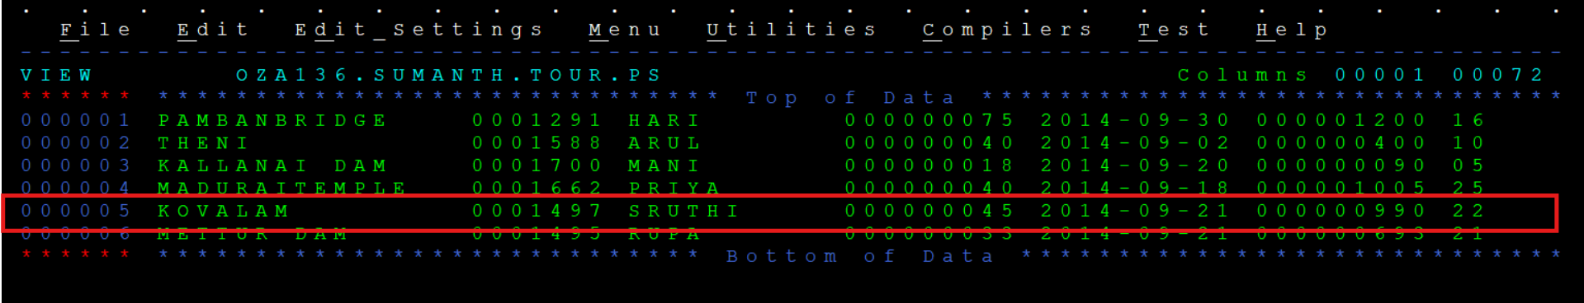

SEASON_DISCOUNT Table:



### **Test Case ID: TC08**

**Test Case Description:** Determine the FINAL_PRICE for discounts ranging between 51 and 99.

**Input Data:**

Record: PAMBAN BRIDGE, HARI, TAM, 2014-09-30, 16, 2500

DISCOUNT: 75

GROUP_DISCOUNT: 75 * 16 = 1200

Formula: FINAL_PRICE = PRICE_PER_HEAD - GROUP_DISCOUNT - 9

Expected: FINAL_PRICE = 2500 - 1200 - 9 = 1291



**Output Data:**

Calculated FINAL_PRICE: 1291

OUTTOUR record:

**PAMBAN BRIDGE 0001291 HARI 000000075 2014-09-30 000001200 16**

**Conclusion: PASS**

FINAL_PRICE calculated correctly for DISCOUNT between 51 and 99.

OUTTOUR file:

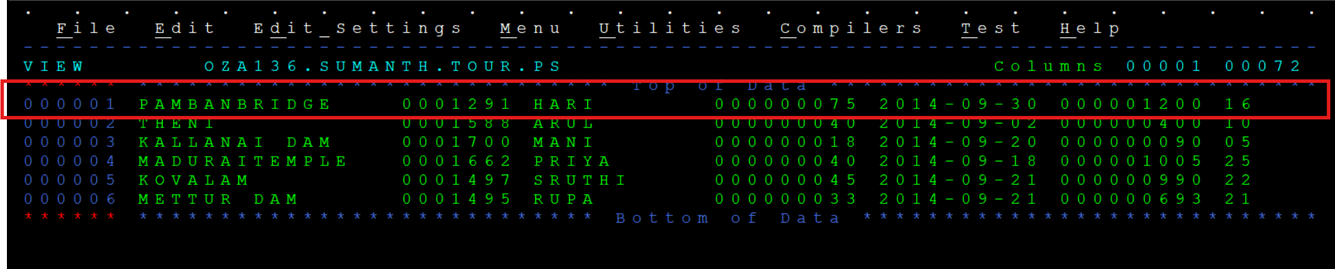

SEASON_DISCOUNT Table:



## **Version History**

|  |  |  |  |
| --- | --- | --- | --- |
| **Version** | **Date** | **Author** | **Changes Made** |
| 1.0 | 19-03-2025 | Sumanth Kumar Reddy | Initial draft created. |
| 1.1 | 20-03-2025 | Sumanth Kumar Reddy | Added test cases, result and screenshots. |
| 1.2 | 20-03-2025 | Pranchan Biswas | Signed-off and final review. |